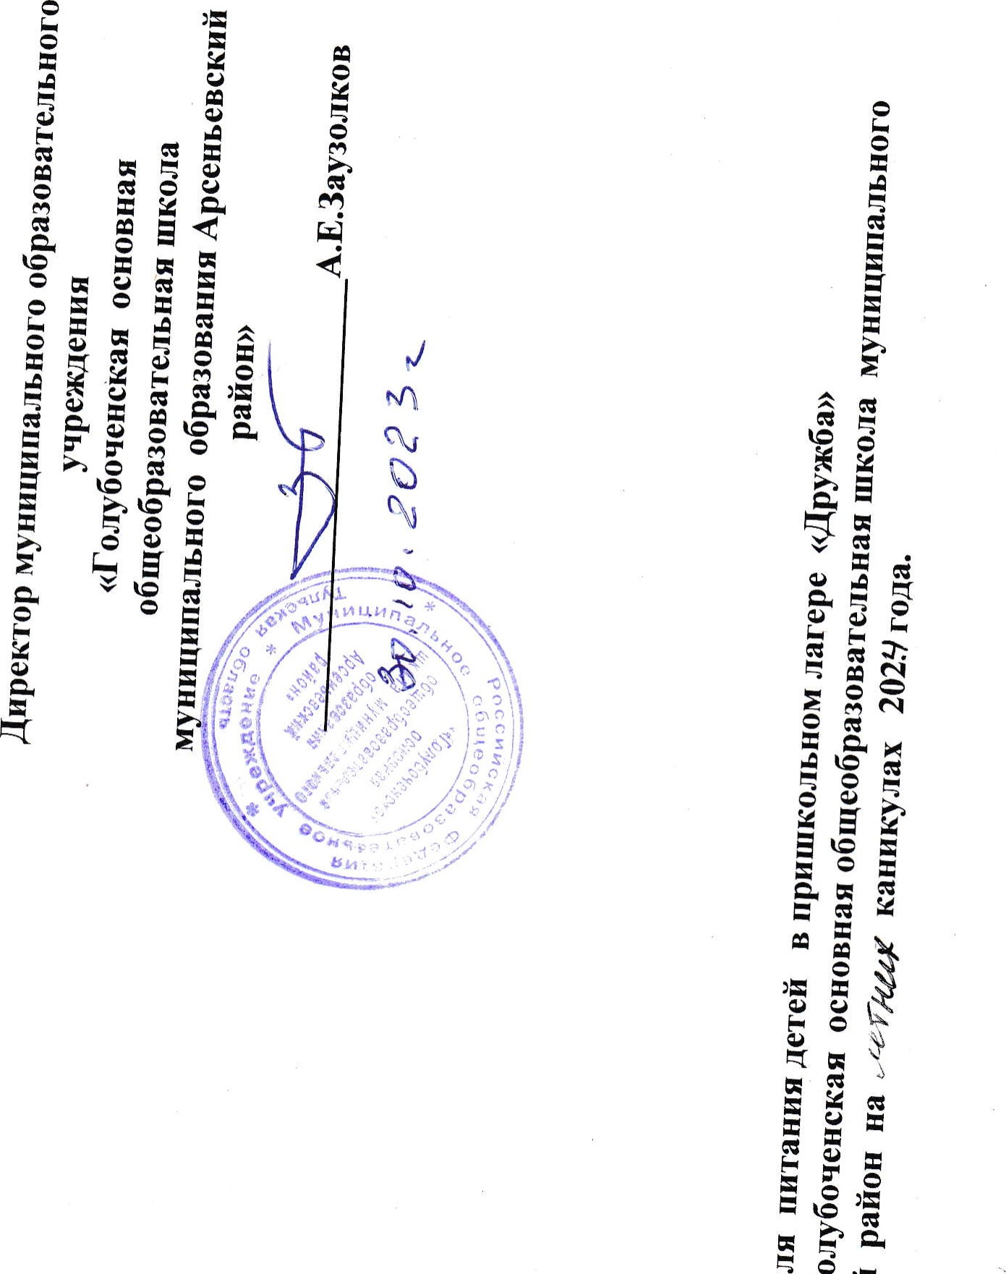
!Ⅱ
0
5
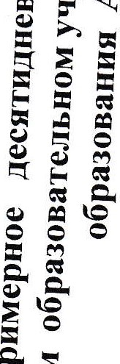
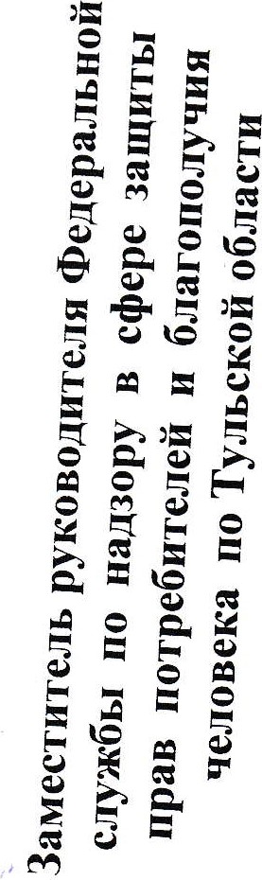
1
300 |  |  |  | 389 |  | 36 | 353 | 134 | 4(25) |  |  | 116 | 29 | 496 | 182 | 300 |  |  | rreXHOJIOrnqeCKO  KaPTbI~
CHe)KOK | KeKCaeTCKHÏI | 110 HH | IITOFO | COKd)PYKTOBb1Ï1 | XJ1e6p)KaH0ìí | Te(þTeJIH MHCHbIe | PHCOTBaPHOñ | PaCCOJIbHHK  <<JleHHHrpaÄcKHìí>> | CaJIaTH3  6eJIOKOqaHHOH  KallYCTbI  冖KBaIIIeH0ìí  KallYCTbI) | 06 | HTOFO | XJ1e611111eHHt1Hb1ü | Cb1P | KaKaocMOJIOKOM | Kama  MOJIOLIHaqHI-IIeHHaq | AìíuaBapeHbIe | 1-ìíneHb-3aBTaR | 1 | HaHMeH()BaHIIe  6 10a
200 | 75 |  |  | 200 | 90 | 100 | 200 | 250 | 100 |  |  | 45 | 40 | 200 | 210 | 40 |  | 4 | Macca  1101)IUIU
5」6 |  |  | 39·9 |  |  | 18 | 4·6 |  |  |  | 27·9 |  | 3 |  | 4」6 | 12」7 |  | 5 |  | 1111111eBbIeBemeCTBa(r)
 | 12」8 |  | 48·4 |  |  | 27·8 |  |  | 4」8 |  | 25·25 | o」45 |  | 3」0 | 10」9 | 1P9 |  | 6 |  | 1111111eBbIeBemeCTBa(r)
22 | 42」12 |  | 152·8 | 25 | 34 | 2L0 | 46·2 | 16」6 |  |  | 125·9 | 23 | 44·8 | 23 | 34」4 |  |  | 7 |  | 1111111eBbIeBemeCTBa(r)
156 | 300 |  | 1194·5 |  | 186 | 374 | 246 | 192·5 |  |  | 830·8 |  | 182 | 一3P8 | 246 | 157 |  | 8 | ecKafl neHHOCTb,  KKaJI
 |  |  |  |  |  |  |  | o」1 |  |  |  |  |  |  |  |  | Bl | 9 | BHTaMHHbI(MT)
1 |  |  |  |  |  |  |  | 6 | 25 |  |  |  |  | 0,5 |  | 0,2 | C | 9
 |  |  |  |  |  |  | 28·3 | 188」  5 | 2 |  |  |  |  | 一7」7 |  | 75 | A | 9
 |  |  |  |  |  | 2 |  | 1 | 2 |  |  |  |  |  |  | o」2 | E | 9
116 | 24 |  |  |  |  |  |  | 33 | 30, |  |  |  |  | 1一7  」5 |  | 301 | Ca | 10 | MUHCPaJIbHbIe  BerueCTBa
 |  |  |  | 5 |  | 128 | 94 | 130 | 33 |  |  |  |  | 一04」6 |  | 185 | P | 10
 |  |  |  |  |  | 22·9 | 3L3 | 32」4 | 17」1 |  |  |  |  | 28」9 |  |  | M | 10
 |  |  |  |  |  | 0·9 | 0.6 | 一8 |  |  |  |  |  | o」9 |  |  | Fe | 10

 | 847 |  |  |  | 389 | 398 | 291 | 108 |  |  |  | 116 | 115 | 28 | 20 | 307 | 237 |  |  |  |  | 847 |  | TCXHOJI()rnqeCKO  11KaPTbI,,
net-RHbe | rpy111HCBe)KHe | 110 HH | IdTOFO | XJ1e6P)KaH0ñ | COKd)PYKTOBb1ñ | IleqeHb B b  110,CTPOraHOBCKH | MaKaPOHb1  H3ÄeJIH¶OTßaPHbóeS | CynKPeCTb¶HCKHü | CaJ1aTH3 CBe)KHX 110MHAO CJIYKOM | 06 | HTOFO | XJ1e6 11111eHHHHb1ñ | Xne6p)KaH0ìí | MacJ10CJIHBOHHOe | qaìí ccaxap0MH  JIHMOHOM | KOTJ1eTaMHCHaq | KamarpeLIHeBa¶  paccbIIIqaTa¶ | 2丨 neHb-3aBT |  | HTOFO | IdTOFO | 6 OKHCBe)KHe | 1 | Hal•1MeHOBaHwe  6 10a
 |  |  |  |  |  |  |  |  |  |  |  |  |  |  |  |  |  | aK
100 | 200 |  |  | 90 | 200 | 100 | 200 | 250 | 100 |  |  | 45 |  | 15 | 200n5n | 100 | 200 |  |  |  |  | 200 | 4 | Macca  nopIÅHH
20」5 |  |  | 42·2 |  |  |  |  |  |  |  | 79·25 |  |  | 0·15 |  | 19」8 |  |  |  | 81·9 | 14·1 | 08 | 5 | 6e | 11111110bIeBerueCTBa冖r)
 | o」6 |  | 273 |  |  |  |  |  |  |  | 42·05 |  |  | 12·45 |  | 14」6 | 10」7 |  |  | 91·45 | 17·8 |  | 6 |  | 11111110bIeBerueCTBa冖r)
66 | 17」6 |  | 123·9 | 34 | 22」4 |  | 45·1 | 一2」5 |  |  | 10P5 | 0·45 | 17·0 | P15 |  | 15 | 58·4 |  |  | 382·42 | 103·72 | 39·6 | 7 |  | 11111110bIeBerueCTBa冖r)
470 |  |  | 933·8 | 186 | 90 | 17L8 | 280 | 182 | 24 |  | 856·8 | 23 | 93 | 112·5 | 38」8 |  | 328·4 |  |  | 2258L3 | 556 | 20 | 8 | t)HePreTHtI  ecRaq  neHHOCTb,  KRaJI
 |  |  |  |  |  | 0.2 |  |  |  |  |  |  |  |  |  |  |  |  |  |  |  |  | 9 | BHTaMHHbI(MT)
 |  |  |  |  |  | 14 |  | 一0 | 7 |  |  |  |  |  | 1 | 1 |  |  |  |  |  | 60 | 9
 |  |  |  |  |  | 711 | 47·2 | 92」7 | 180 |  |  |  |  | 0·12 |  | 2」一 | 47」2 |  |  |  |  |  | 9
 |  |  |  |  |  | 2 | 2 | 3 | 4 |  |  |  |  |  |  | 29 | 7 |  |  |  |  |  | 9
 |  |  |  |  |  |  |  | 44 | 16 |  |  |  |  |  |  | 32 | 24 |  |  |  |  |  |  | MHHCPaJIbHb1e  Bell-ueCTBa
 |  |  |  |  |  | 3L3 |  | 122 |  |  |  |  |  |  | 6 | 207 | 254
 |  |  |  |  |  | 19·8 |  | 27一8 |  |  |  |  |  | 3 |  | 4P7 | 171
 |  |  |  |  |  | 6·7 |  | 1,9 |  |  |  |  |  |  |  | 2」一

 | 389 |  |  | 24 |  |  | 388 | 429 | 128 | 3 |  |  | 501 | 116 | 366 |  |  |  | 300 |  | TeXHOJIOTHqeCRO  RaPTb1,
FIHPOFCMaKOM | COK(þPYKTOBb1ñ | 110 HH | HTOFO | KHCeJIb toc卜 、丶卜  IlJIOAOWOAHbIH  (BHT.C) | 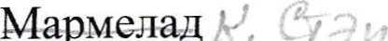 | XJ1e6P)KaHOñ | KOTJIeTapb16HUI | KapT0(þeJ1bH0e  Il}ope | BOPIIIcKanycT0ìí  HKapTOeJIeM | CaJIaTH3CBe)KHX  OFYPI-IOB | 06 | IlTOFO | eñHbIìí  HallHTOKC  MOJIOKOM | XJ1e6 11111eHHHHb1ìí | TBop())KHaq  3aIIeKaI--IKaCO  CFYII-IeHHbIW  MOJIOKOM | 3丨 aeHb-3aBT aK | HTOPO | HTOTO | PIOTYPT11HTbeB0ü | 1 | HallMeHOBaHHe  6 K) a
100 | 200 |  |  | 200 | 50 | 90 | 100 | 200 | 250 | 100 |  |  | 200 | 45 | 200B0 |  |  |  | 200 | 4 | Macca
 |  |  | 46·51 |  |  |  |  |  |  | 1」21 |  | 4L8 |  |  | 37·3 |  | 146·25 | 24·8 |  | 5 | H | 1111111eBbIeBerueCTBa冖r)
 |  |  | 30·7 |  |  |  | to |  |  |  |  | 27·7 |  | P45 | 24」0 |  | 84·55 | 15·2 |  | 6 | }KHPbI | 1111111eBbIeBerueCTBa冖r)
53」7 | 27」7 |  | 128·75 | 30」8 |  | 34 | 一4」9 | 26」3 | 一0」2 | 5」55 |  |  | 19·6 | 523 | 46」4 |  | 313·6 | 89·2 |  | 7 | yTJIeBOAbI | 1111111eBbIeBerueCTBa冖r)
299 |  |  | 978 | 120 | 100 | 186 | 一77」6 | 173 | 1364 |  |  | 783·4 | 127 |  | 5414 |  | 2415·2 | 624·6 | 70一6 | 8 | 9HepreTIIII  ecl•caq neHHOCTb,  KKaJI
 |  |  |  |  |  |  |  | o」2 |  |  |  |  |  |  |  |  |  |  |  | 9 | BHTaMHHbI冖MT)
 | 一2 |  |  | 2 |  |  | 1 | 一4 |  |  |  |  |  |  |  |  |  |  | 1 | 9
34」9 | 2」3 |  |  |  |  |  | 一3」3 | 32 | 160」  5 |  |  |  |  |  | 5一」9 |  |  |  | 25 | 9
一 |  |  |  |  |  |  | 3 |  |  |  |  |  |  |  | 一 |  |  |  |  | 9
152 | 23」 |  |  |  |  |  |  | 51 |  |  |  |  | 12 |  | 125 |  |  |  | 150 |  | MllHepaJIbHbIe  BerneCTBa
116 |  |  |  | 9 |  |  | 271 |  | 106 |  |  |  | 5 |  | 134 |  |  |  | 11
 |  |  |  | 5 |  |  |  | 38」7 | 3L3 |  |  |  | 4一6 |  | 22」8 |  |  |  | 17」5
 |  |  |  |  |  |  |  | 一」5 | 2」0 |  |  |  |  |  |  |  |  |  | 0,8

 |  |  | 508 |  |  |  | 39冖22) |  |  | 29 | 300 | 496 | 116 | 4 |  |  |  | 444 |  | TCXHOJIOrnqeCRO  KaPTbI丨 、
110JIAHHK | IlTOFO | XJ1eõp)KaH0ñ | KOMIIOTH3CMeCH  cyxo  (BHTaMHHC) | COCHCKHOTBaPHb1e | Kan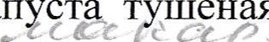  T  IlleHaq | CynPb16Hb1ìí | CanaT  BHTaMHHHbIH  (CaJ1aTH3  KaPT*1TL¶C  3eJIeHbIM  FOPOIIIKOM) | 06 | HTOPO | Cb1P | BapeHbIe | KaKaocMOJIOKOM | XJ1e6 11111eHH¼Hb1ñ | KamaaccopTH  仌Apy 6a一一 | 4丨 AeHb-3aBT aK | HTOFO | HTOTO | MaHÄapHH | 1 | HaHIMeHOBaHne  6 Iona
 |  | 90 | 200 | 一00 | 200 | 250 | 100 |  |  | 20 | 40 | 200 | 45 | 250n0/5 |  |  |  | 200 | 4 | Macca
 | 28·3 |  |  | 10·8 |  |  |  |  | 32 |  | 12·7 |  | 13·8 | 10」2 |  | 99·91 | 1L6 |  | 5 | 6e H | 1111111eBbIeBellIeCTBa冖r)
 | 40 |  |  | 23·2 |  | 2」4 | 7」2 |  | 30·15 |  | 10·9 |  | P45 | 15」8 |  | 63·7 |  |  | 6 |  | 1111111eBbIeBellIeCTBa冖r)
 | 128·1 | 34 | 28 |  | 26」3 |  |  |  | 118·9 | 22·4 |  | 23」0 | 23 | 49」8 |  | 324·55 | 106·8 | 25」4 | 7 | yrJIeBOAbI | 1111111eBbIeBellIeCTBa冖r)
 | 965·8 | 186 | 100 | 242·9 | 173 | 87」3 | 一01」3 |  | 870·6 | 96 | 157 | 一30」8 |  | 3718 |  | 2268·4 | 507 |  | 8 | 3HepreTH¼  ecRaq neHHOCTb,  RIOJI
 |  |  |  |  |  |  |  |  |  |  |  |  |  | o」2 |  |  |  |  | 9 | BHTaMMHbI(MT)
 |  |  |  |  |  |  | 32 |  |  | 5 |  | 1 |  | 一 |  |  |  |  | 9
 |  |  |  |  | 32 | 22一5 | 69」4 |  |  |  |  | 一7一7 |  | 977 |  |  |  |  | 9
 |  |  |  |  |  |  | 3 |  |  |  |  |  |  | 1 |  |  |  |  | 9
 |  |  |  |  |  |  | 40 |  |  | 5 |  | 118 |  | 247 |  |  |  |  |  | MHHePaJIbHbIe  Bell.ueCTBa
 |  |  |  |  |  |  | 25 |  |  | 46 |  | 10·5 |  | 258
 |  |  | 一8」1 |  | 38·7 |  |  |  |  |  |  | 28。9
 |  |  | 0,7 |  | 1.5 |  |  |  |  |  |  | 0,9 |  | 1

HaHMeHOBaI-Ine ecRaq BCIIIeCTBa CXII()JI()rnqeCKO 6 K)a ueHHOCTb, iiRaPTb1丨 KRaJI

1 4 5 6 7 8 9
244 AlleJIbCHH 200 1 34 186
300 HorypT11HTbeB0ìí 一25 70」6 一7一5
KeKC 12」8 42」12 300
WTOFO 16·8 16·9 5L72 58L6 IdTOFO 78·6 87·05 298·72 2418
E
—
丨
丨
丨
丨
丨
I
5, neHb-3aBT aR
106 OBOII丶H 100 1381 HaTYPaJIbHbIe
CBe)KHe冖orypeu)
301 OMJIET 200 14·4 23·1 2·85 28047」2 12 13 HaTYPa-T1bHb1H
105 0 CJIHBO¼HOe 15 P15 12·45 P15 112·8
CcaxapoMLlaìí 200 38」813 6 JIHMOHOM
XJ1e6P)KaH0ñ P45 23
XJ1e6 LillieHH¼Hb1ñ 45 15·7 93
11TOFO 22·5 36·6 5L7 653·4

06
一6 C&J1aTH3CBeKJIbI 100 15P26 29 34 一7」5
142 I_I_IH113 冖 250 155」248 100 KallYCTbIC
144 H3Pary1THLIbI1 280 2L42 35 2L56 487·2241 16」7 1,8 389 COK(þPYKTOBb1ñ 200 29·7 12036 16·2 0,7
XJ1e6p)Kff10ìí 90 34 186
HTOFO 37·02 58·7 10P56 1098·9

110 HH
3ed)HP 57 210

Macca INHIueBbIeBellÅeCTBa冖r) BHTaMHHbI(MT) MHHePaJIbHbIe

HCIIOJIb3yeMaHC60PHH一0HOJIHTeparrypa:0n000 03A()POBwreJ1bHb1XHOPM,n000, 00en p0=、2011 丶, 0-Hb1 00·HH3a,
~Il0bHb opraHH3aunìÍ
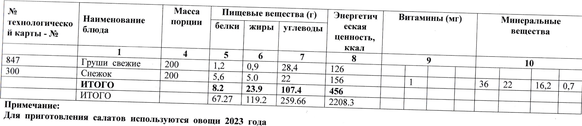
111C60PHHK0- no00enp aRPH-ne0B.A.K) ~HHapH-M00H0 000~,r.n00·丶 aT, b0T0000W00丶丶x0000nP0=00 OPM、 一∕ npH000000N00,」0-H-
,M.A.CaHIInHOpraHH3a11H¶beJ10ycoBa,·3 ·11HTaHH¶·T.A.~000MaRcHMIIeBa.0 11100“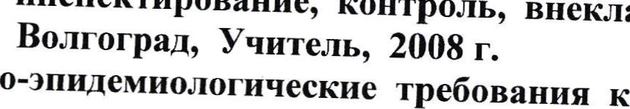HHcne n000,Hue一OH一PO =eK,00HopraHH3auHH,:0,00,00=000~一BeHHO- 00乛0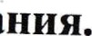AB00,000」00n0=-
yqHTeJ1b,
2008
r.

